Optimization in Complex Biological Networks: Tradeoff between Efficiency and Robustness in Network Design

Priyan Patkar, Leaelaf Hailemariam, and Venkat Venkatasubramanian

Laboratory of Intelligent Process Systems, School of Chemical Engineering, Purdue University, 480 Stadium Mall Drive, W. Lafayette, IN 47907-2050

Networks appear in graphs of telephone calls, the overlapping boards of directors of the largest companies in the U.S., the Internet, the relation between words and so on (1). Of these, a significant fraction could be thought of as transportation networks: power grids (electricity), vascular networks (nutrients in human body), the Internet (information). In all of the above, the structure of the network affects the behavior. As a primary example of transportation networks, the structure of food webs has been subject to much scrutiny. Food webs have shown some universality in their size and low connectance (Dunne et al., 2002). In this paper, the authors propose a new parameter in food web analysis, called the energy flow potential and demonstrate an interesting trend appearing for several food webs from literature, suggesting the universality based on a common design principle: optimization between the need to provide for every species (efficiency) and the need to protect against damage caused by the loss of one or more species in the web (robustness). As food webs are in essence transportation networks for nutrients/energy, the principles derived and the model developed could be extended to other transportation networks like river networks, the Internet, road networks and blood flow networks.

Food webs are defined as networks of consumer-resource interactions among a group of organisms (Polis and Winemiller, 1996) and represented by complex networks linking the predators and prey (Caldarelli et al., 2003). These network structures appear to display some universality: low clustering and small network diameter (Dunne et al., 2002). Several attempts had been made to identify structural universality between food webs in hopes of discovering the underlying assembly principle: constant connectance (Solow and Beet, 1998), reliability of flow (Jordan and Molnar, 1998). Several authors ( Williams and Martinez , 2000; Cattin et al. , 2004) proposed models which considered an energy space for each specie to consume from, whose width, position and number of included species (which can then be consumed) determined by probabilistic distributions. Garlaschelli et al. (2003) considered food webs to be transportation networks and developed an exponential relation between the capacity of the system and the energy passing through it.

In the present work, the authors propose a new parameter in food web analysis, called the energy flow potential. This parameter was defined and tested for food webs from literature. An interesting trend appears, suggesting the universality based on a common design principle. The energy flow potential is described below.

- The energy flow potential

One can represent of a small part of a hypothetical food web as in Figure 1.
k_{i}
m_{j}

Figure 1: Schematic representation of the parameters k and m

In the above, k_{i} represents the number of prey a species (i) has and m_{j} represents the number of predators a species (j) has. The combination 1/ (k_{i}m_{j}) (called the Energy Flow Potential) in some sense captures the probability of species i managing to eat species j. 1/ (k_{i}m_{j}) can be considered a ‘localized’ property while the sum of 1/ (k_{i}m_{j}) over all the links in the web, and the average of 1/ (k_{i}m_{j}) over all the links in the web can be considered as systemic properties.

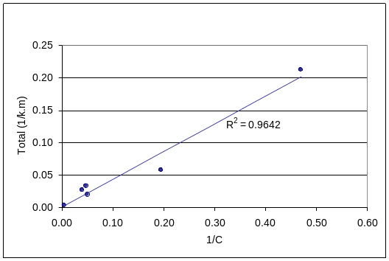

Comparison with food web data of Total (1/km)

Using this analysis, food webs were found to have properties between a star (Slope =0) and fully connected network (Slope = 1); between a ternary tree (Slope = 0.33) and a binary tree (Slope = 0.5)

[Table for values for fully connected, MST, circle, …… here ]

- Growth of random networks over binary and ternary trees

An interesting continuation to the results obtained from the Niche model is the growth of a network from an initial skeleton of a binary or ternary tree by random addition of nodes to a fully connected graph. The following plots are observed for an intermediate number of nodes.

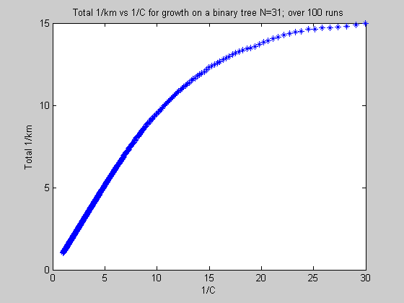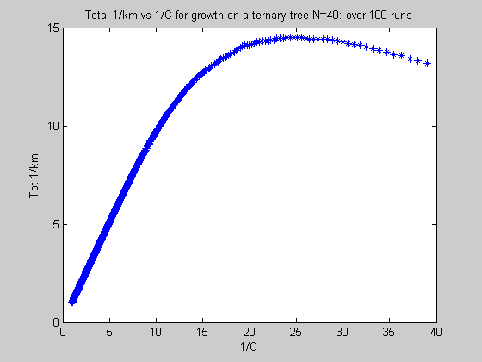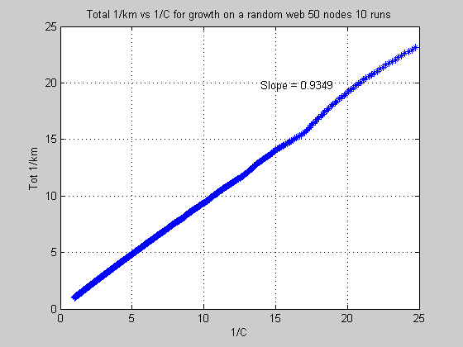
(a) (b) (c)
Fig. 6: Plot of Total 1/km vs 1/C for random growth on (a) binary tree (b) ternary for 31 nodes (c) random network of 50 nodes [R²=0.9997]

One could immediately note that there are at least two regimes visible in both Fig. 5 and Fig. 6, a linear regime close to the origin and a non-linear regime starting at approximately S²/L² = 0.2 for Fig. 5 and 1/C =10 for Fig. 6. One can also note how most of the points appear to lie in the linear regime, especially in Fig. 5.

A similar procedure was carried out for growth over a ternary tree.

A minimum spanning tree was defined and edges were randomly and progressively added to same. The following parameters were considered:

Aside from the behavior noted for growth on a binary tree, one can note a ‘peaking’ effect in Fig. 8. If Total 1/km is some measure of the ‘goodness’ of the network, the above figure would suggest that the ‘goodness’ we are seeking is maximized at connectance of about 0.04 if our network is grown randomly in the manner given .
As addenda, one can consider the evolution of average k and average m as the network grows over a binary and ternary skeleton.

Comments: The behavior of the two plots above appears to show an unprecedented fit. This might suggest an underlying relation between the parameters which might evoke the theoretical degree distribution of random graphs and related mathematical relations.

References

Latora, M. and Marchiori, M., Is the Boston subway a small-world network?, Physica A, Vol. 314, p. 109, 2002

Caldarelli, G. et al., Food Web Structure and the Evolution of Complex Networks, in Statistical Mechanics of Complex Networks, Eds. Pastor-Satorras, R., Rubi, M. and Diaz-Guilera, A., Lecture Notes in Physics, Springer-Verlag, Germany, 2003

Cohen, J.E., Food Webs and Niche Space, Princeton University Press, Princeton, 1978

Doledec, S., Chessel, D. and Gimaret-Carpentier, C., Niche separation in community analysis: a new method, Ecology, Vol. 81, No. 10, p. 2914-2927, 2000

Dunne, J.A., Williams, R.J. and Martinez, N.D., Food-web structure and network theory: The role of connectance and size, Proceedings of the National Academy of Sciences, Vol. 99, No. 20, p. 12917, 2002

Garlaschelli, D., Caldarelli, G. and Pietronero, L., Universal scaling relations in food webs, Nature, Vol. 423, p. 165, 2003

Jordan, F. and Molnar, I., Reliable flows and preferred patterns in food webs, Evolutionary Ecology Research, Vol. 1, p. 591-601, 1999

Polis, G.A. and Winemiller, K.O., Food Webs: Integration of Patterns and Dynamics, Chapman and Hall, International Thomson Publishing, Florence, KY 1996

Solow, A.R., On the goodness of fit of the cascade model, Ecology, Vol. 77, No. 4, p. 1294, 1996

Solow, A.R. and Beet, A.R., On lumping species in food webs, Ecology, Vol. 79, No. 6, p. 2013, 1998

Strogatz, S.H., Exploring Complex Networks, Nature, Vol. 410, p. 268, 2001

Williams, R.J. and Martinez, N.D., Simple rules yield complex food webs, Nature, Vol. 404, p. 180, 2000

===============================================================
Table 1: Food webs to be modeled by the Niche model

Food Web Name | Number of Trophic Species N | Connectance C
Skipwith Pond | 25 | 0.32
Little Rock Lake | 92 | 0.21
Bridge Brook Lake | 25 | 0.17
Chesapeake Bay | 31 | 0.072
Ythan Estuary | 78 | 0.061
Coachella Valley | 29 | 0.31
St. Martin Island | 42 | 0.12

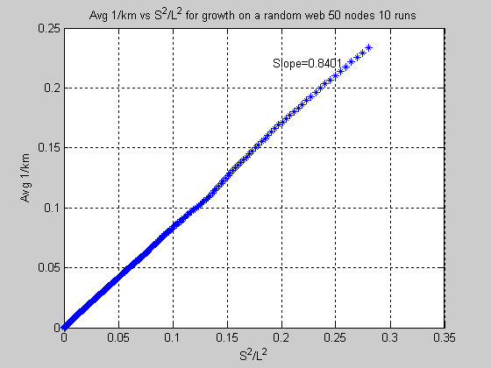

Fig.2. The relation b/n Average 1/(km) and S²/L² for network ‘growth’ over a random spanning tree with 50 nodes averaged over 10 runs [R²=0.9998]

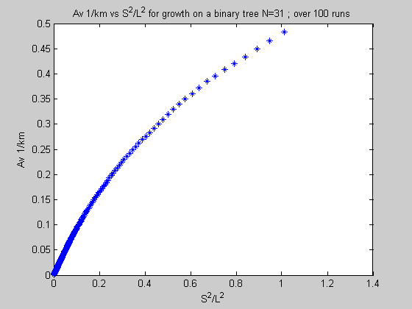

Fig. 5: Plot of Average 1/km vs S²/L² for random growth on a binary tree for 31 nodes

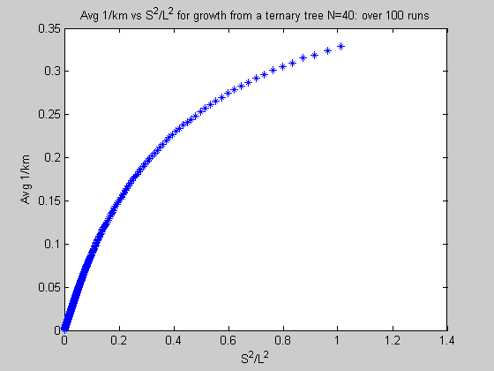

Fig. 7: Plot of Average 1/km vs S²/L² for random growth on a ternary tree for 40 nodes

The structure of these networks always affects their function (Strogatz, 2001); hence the exploration of food web structure is one of the major issues of modern ecology. Understanding how communities are assembled is expected to give insight into the organization of natural ecosystems. As food webs are also transportation networks (Garlaschelli et al., 2003), tools developed in the study of food web topology analysis are expected to be applicable to other transport networks as well.

Growth on a random web

- The number of species a species i, currently eating a specie j, could have eaten directly (k)
- The number of species that could eat j directly (m)
- The sum of all the 1/km values of all the edges
- The average of the 1/km values of all the edges
- The connectance of the network C (number of links/(number of species*(number of species-1)) for no cannibalism
- Number of Species²/ Number of Links² (S²/L²)

The results are shown below:

Fig.1. The relation b/n Total 1/(km) and 1/C for network ‘growth’ over a random spanning tree with 50 nodes averaged over 10 runs

and demonstrate the utility of the same by relating it to other more familiar network parameters like connectance and the vertex degree of nodes the utility of the same by relating it to other more familiar network parameters like connectance and the vertex degree of nodes. An. Comparing food webs by searching for regularities in them is of fundamental importance, as that would suggest a common principle underlying their organization (3)
As such, several structural properties of food webs; connectance, fraction of top, bottom and intermediate species, average path length, degree distribution etc have been seen to affect such other properties as robustness and efficiency of the network. Food webs also display some universality: although they cannot be described as small worlds because of their low clustering, they possess much of the properties of the same due to their small network diameter (2).

question and the source of energy (the Sun) at a particular step, and the number of species at that step that will get energy from that ‘step’. They found that food webs appear to follow a similar exponential law.

presented their niche model, in which species were assigned niche values and constrained to eat species which have niche values within a range whose center is less than the predator’s niche value.

Cohen and Newman proposed the cascade model of food web assembly (Solow, 1996) in which species were given a ranking and constrained to eat respectively one of the species with a rank lower than themselves with a probability inversely proportional to the number of species in the community. Solow and Beet (1998) proposed the constant connectance model, in which a species was made able to prey on any other species including itself with a constant probability. Jordan and Molnar (1999) analyzed the structure of food webs from a reliability point of view: reliability defined as the probability that sources are connected to sinks. Patterns favorable to reliable flow were found to be the majority in the actual food webs studied; pointing to the possibility that reliability could be one of the underlying principles of food web construction.
presented a modification of the niche model of Williams and Martinez, wherein species are not constrained to eat only in a range and niche overlaps are considered. The Cattin model predicted better the noncontiguous nature of ecological niches (i.e. species can eat from several disjoint niches).
, populations or aggregate trophic units They are an important example of complex networks and can be defined as a directed graph with vertices representing species and links pointing from predator to prey

===========================================================

- The Niche Model (Williams and Martinez, 2000)

The ecological niche is defined as” an n-dimensional hypervolume, defined by functional relationships between species, within which the population of a species can persist” (Doledec et al., 2000). If two kinds of organisms, say A and B both eat a third species C, then, along some trophic dimensions, their niches must intersect or overlap. However, this overlap may not need to be physical: a fish A and bird B can both eat an insect C that lives on the interface of water and air without either infringing on the other’s physical domain. Thus “niche overlap” means “niche overlap over trophic dimensions” unless stated otherwise. By defining a niche to be the amount of trophic space allocated to one organism to feed from, Williams and Martinez (2000) presented a simple model that successfully predicts key structural properties of the most complex and comprehensive food webs in the primary literature.

A schematic of the niche concept is shown in Figure 1. In the niche model, the species is constrained to eat only those species whose ‘niche value’ n_{i} falls within its niche centered at c_{i} with width r_{i}. The niche value n_{i} is set by taking a random number b/n 0 and 1. The niche width r_{i} is then calculated by: r_{i} = n_{i} x β(1, B) where β(1, B) is a Beta distribution with B=1/(2C) – 1, where C is the connectance of the food web to be modeled. The niche center is taken randomly from the range [r_{i}/2, n_{i}]. Using the average over several runs, several structural properties of the simulated food web could be determined.

1
0
The Specie is here
n_{i}
r_{i}
Niche center for the specie c_{i}
Figure 2: Schematic representation of the Niche model

For the present work, the food webs shown in Table 1 with corresponding properties were used.

Several phenomena of interest are observed on analysis of the resulting food webs. For instance, the plot of the sum of 1/ (k_{i}m_{j}) over all the links in the food webs generated by the Niche model using the parameters in Table 1, averaged over several runs , is shown in Figure 3. The linear properties (from Excel ©) are summarized by in Table 2.

Table 2: Linear property of Figure 3 from Excel

Plot Type | Slope | Regression Coefficient
Average 1/km | 0.5056 | 0.9876
Total 1/km | 0.5088 | 0.882

The fact that the models of the food webs seem to fall on a single line is cause for interest as it suggests an underlying principle in the structure of food webs. The distribution of 1/km values in the same 7 food webs from the Niche model is shown in Figures 4 and 5.

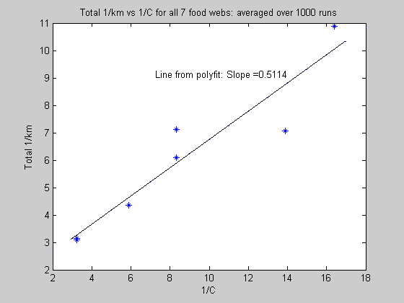

Figure 3: Plot of Total 1/km vs 1/C for the models of the food webs in Table 1

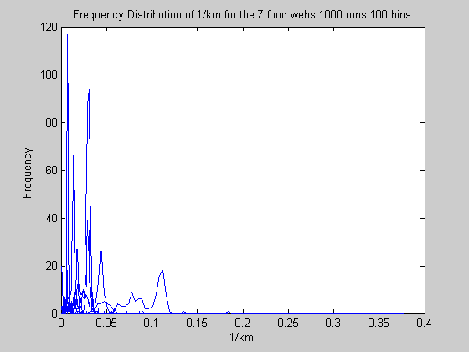

Figure 4: Frequency Distribution of 1/km among the links in the food webs generated by the niche model

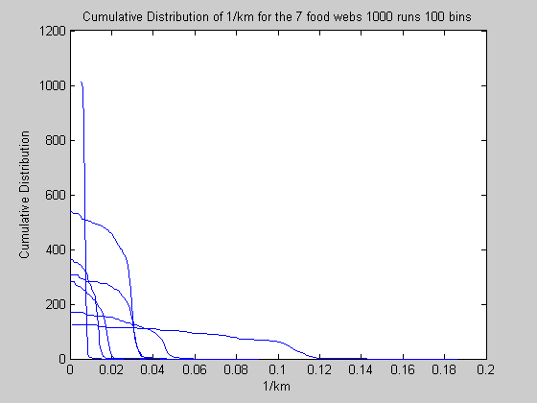

Figure 5: Cumulative Distribution of 1/km among the links in the food webs generated by the niche model

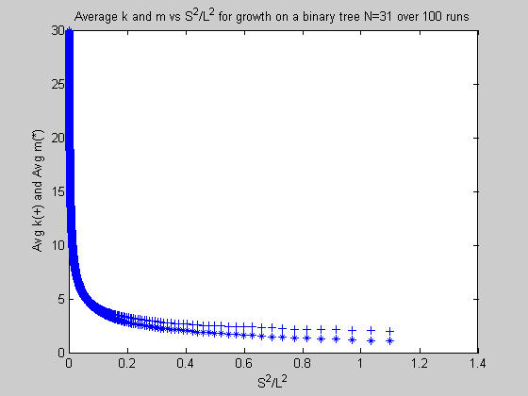

Fig 9: Change of average k and m with S²/L² for growth over a binary tree with 31 nodes

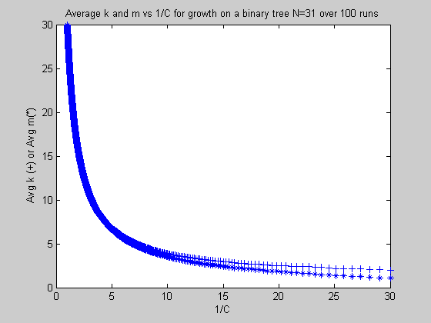

Fig 10: Change of average k and m with 1/C for growth over a binary tree with 31 nodes
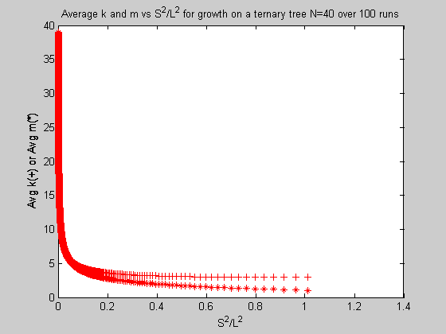

Fig 11: Change of average k and m with S²/L² for growth over a ternary tree with 40 nodes

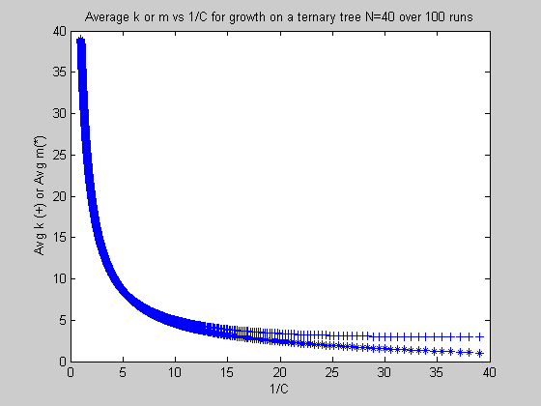

Fig 12: Change of average k and m with 1/C for growth over a ternary tree with 40 nodes

Other combinations of the plotted parameters are also explored.
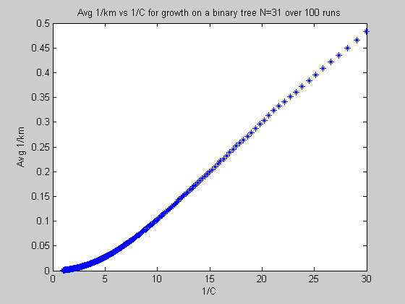

Fig. 13: Change of Average 1/km vs 1/C for growth over a binary tree with 31 nodes

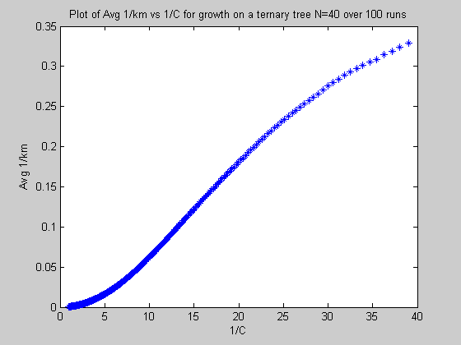

Fig. 14: Change of Average 1/km vs 1/C for growth over a ternary tree with 40 nodes

A thing to note in the above would be a suggestion of sigmoidal behavior for higher order trees eg. quaternary trees.

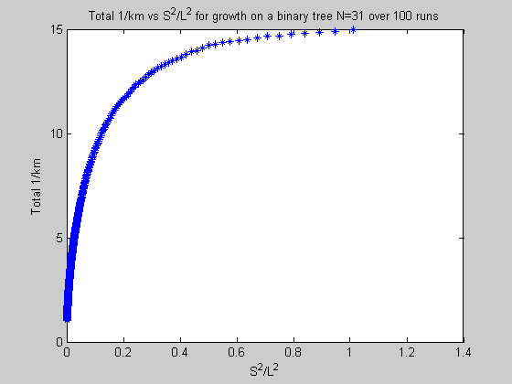

Fig. 15: Change of Total 1/km vs S²/L² for growth over a binary tree with 31 nodes

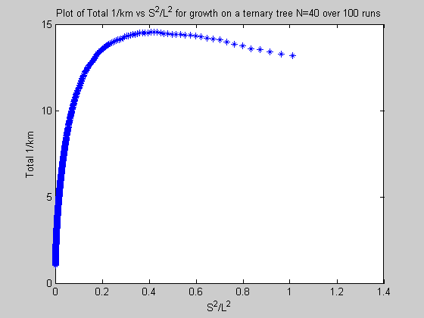

Fig. 16: Change of Total 1/km vs S²/L² for growth over a ternary tree with 40 nodes

The reappearance of a peak in Fig. 16 is indicative of maximization with respect to both 1/C (see Fig 8) and S²/L² above. As the latter is a ‘weighted’ form of the former (S²/L²=1/CL), this could indicate some apparent maximization occurring.

- Appendix

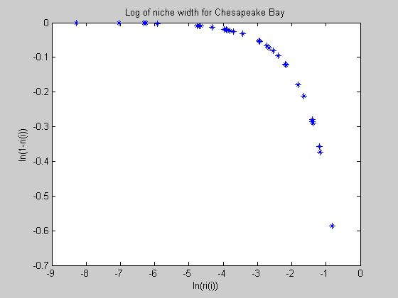

Fig. A1: Concentration of niche width for Chesapeake Bay

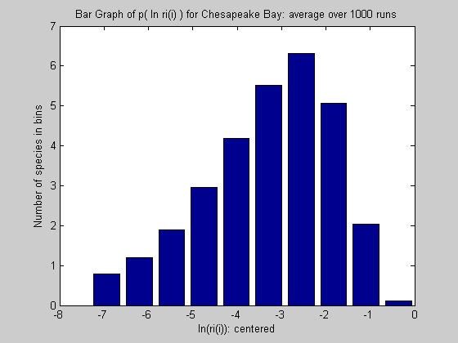

Fig. A2: Number of species with different ranges of niche width for Chesapeake Bay

- The Cattin Model (Cattin et al, 2004)

Species sometimes do not eat all the species in their niches; hence some error is expected to be introduced into the Niche model. Hence, the Cattin model was proposed to rectify it. The model has the following steps. All the species were given niche values in the same way as the niche model and ranked based on those values. The number of links per consumer was set using the niche model but not the identity of the prey. The predators will then choose their respective number of prey from the species ranked below them at random. If predator i chooses a prey j which, before being chosen, had no predators, the predator chooses its next prey from the species with rank less than its own rank. If predator i chooses a prey j which already has one or more predators, predator i chooses its prey from the set of prey of those predators. If predator i tries to choose a prey j but is unable to because there are fewer species with rank less than i than is predicted from the niche model, predator i chooses a prey from the list of species with no predators. Using this model plots of Total (1/km) vs 1/C and distributions of (1/km) values over the links were generated.
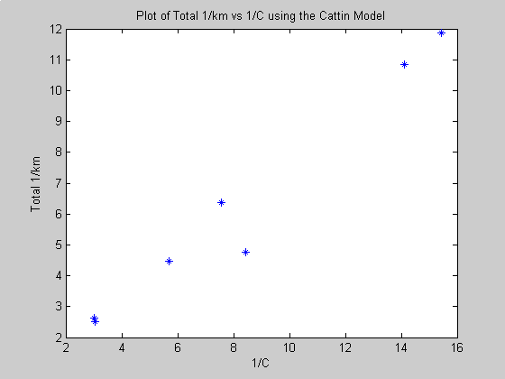

Figure 6: Plot of Total 1/km vs 1/C for the models of the food webs in Table 1 generated using the Cattin model [Slope = 0.744; R²=0.9613]
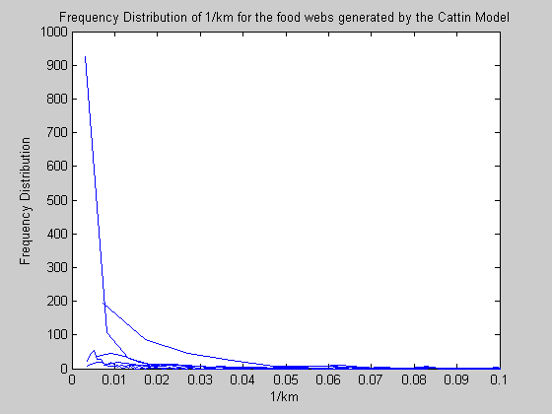
Figure 7: Frequency Distribution of 1/km among the links in the food webs generated by the niche model
References

Growth of ‘eta’ trees

Trees were generated by the following way:

- A binary/ternary/combination/random tree with just enough edges to be a minimum spanning tree was defined.

- An edge was added at random where there was no edge before.

- For the ‘web’ that results, the following analysis done by Garlaschelli et al (2002) was duplicated.

  - The shortest path from a producer to every other species is found. In this work, the shortest paths between all the species are found. This might make the food-web ‘more efficient’ than need be.

  - A more ‘efficient’ web results, for which all subsequent analysis (for only one edge added ) is done

  - For this web, the following parameters were calculated for every node i:

    - A(i): the number of species feeding directly or indirectly on i. This is determined by tracking a path from a top predator to the species. All top predators would have A(i) value of 1.

Although in this constructed food web there is initially only one top predator, this might not be the case for random webs: even for trees, cases are common that the top predator may cease to be ‘top’ because a predation link is established between it and another ‘lower’ species. In this case, one can temporarily assign the species with the smallest number of predators to be a ‘top’ species. In effect that species would act as a resource ‘sink’.

- C(i): is the summation of the A(i) of all the species used to compute A(i)

- Curve fitting was done on log(C(i)) vs log(A(i)) to find a slope η

  - With the above web, the following parameters were computed:

- Average (1/km)
- Total (1/km)
- S²/L²
- 1/C where C is connectance
- Average k and average m
- One more link was added and step 3 was repeated.

- The results were averaged over several runs.

The plots of the results are shown below.

Note: The following ‘rule of thumb’ is used in the upcoming simulations. As each simulation takes a long time (for a single run, required times on the fastest computers available are more than an hour for a 40 node system. The scaling is roughly (N-1)² ). Thus, the lowest number of runs which will provide an acceptable representation of the phenomenon (e.g. Fig. 6) is considered.
1. Binary tree

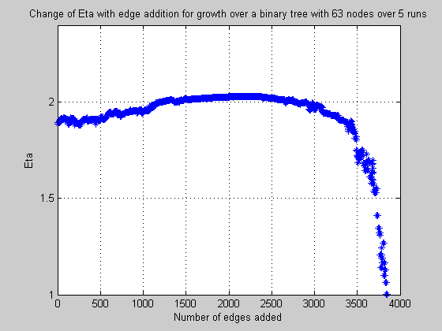

Fig. 3: The change of the parameter Eta with edge addition for growth of a web over a binary tree skeleton with 63 nodes (10 runs)

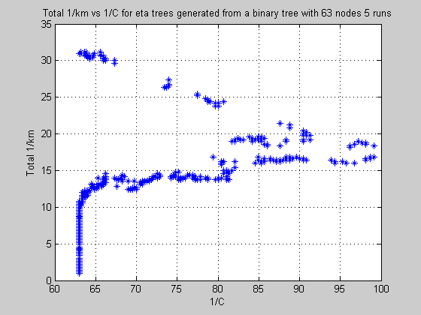

Fig. 4. The relation b/n Total 1/(km) and 1/C for network ‘growth’ over a binary tree and the subsequent reduction to an ‘eta’ tree with 63 nodes averaged over 10 runs

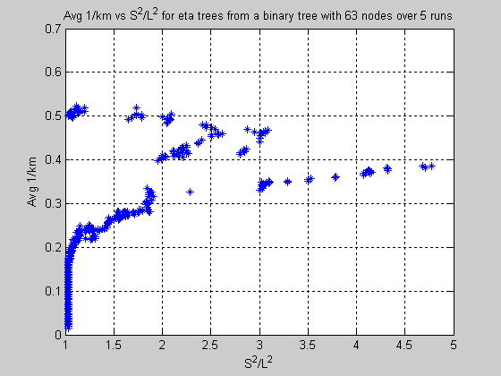

Fig. 5. The relation b/n Average 1/(km) and S²/L² for network ‘growth’ over a binary tree and the subsequent reduction to an ‘eta’ tree with 63 nodes averaged over 10 runs

Comments: The behavior of Eta during node addition is somewhat surprising but could be explained thus. It should be remembered that the process of introducing edges the finding the best path for nutrient flow will change the web structure continuously. As more and more edges are added, the ‘reduced’ tree is expected to resemble a star due to the fact that there will be more realizable shortest paths present. The evolution of the web structure is looked into later in the report.

The ‘rough‘ quality of Fig. 4 and 5 do not lend themselves to convenient interpretation but as the figure will be replicated in other tree types as well, it is thought to be prudent to say a few words at this juncture. The plots seem to suggest (neglecting the outliers) that there are two regimes encountered during ‘growth’: a region in which Total 1/km (or Avg 1/km) appears to show little or no change with a large change in connectance (Region I) and a region in which Total 1/km (or Avg 1/km) appears to grow with little or no change in connectance (Region II).

The following explanation may be forwarded. During the initial stages of growth, where there are still few edges, the addition of a few more, spread over the network, may not change the parameters Total 1/km or Avg 1/km much, although the effect on connectivity might be larger (It should be remembered the 1/km where k and m are the variables affected by the addition of nodes, is probably responsible for that effect by dampening the increase.

Once a critical threshold is passed, however, enough edges would have been available for star-like topologies to appear (the shortest paths being selected) which leads too a major change in Total 1/km or Avg 1/km because it would mean an abrupt release of ‘prey choice’ stress for a predator or, depending on the emerging arrangement, a sudden release of ‘predation variety’. In other words, there will suddenly be only one prey to eat or one predator to escape.

2. Ternary Tree

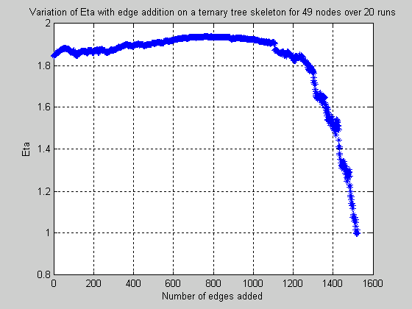

Fig. 6: The change of the parameter Eta with edge addition for growth of a web over a ternary tree skeleton with 40 nodes (20 runs)

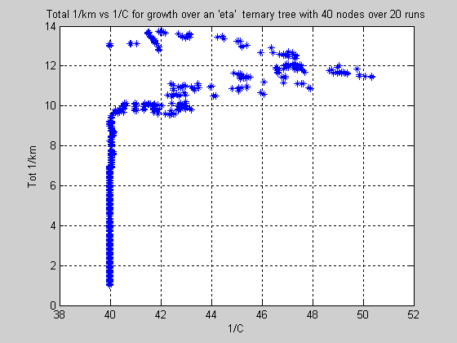

Fig. 7. The relation b/n Total 1/(km) and 1/C for network ‘growth’ over a ternary tree and the subsequent reduction to an ‘eta’ tree with 40 nodes averaged over 20 runs

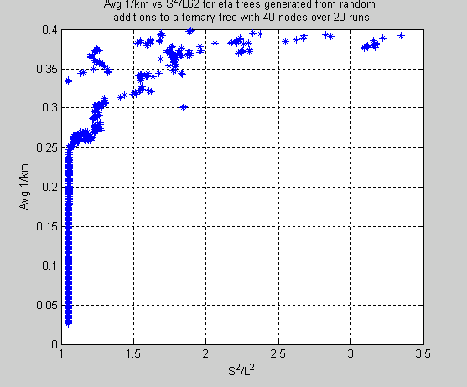

Fig. 8. The relation b/n Average 1/(km) and S²/L² for network ‘growth’ over a ternary tree and the subsequent reduction to an ‘eta’ tree with 40 nodes averaged over 20 runs

Comments: Most of the behavior seen for the binary tree is replicated here. The fact that there seems to be more ‘order’ in some regions in the binary or that the outliers appear to have higher values may be due to the different network sizes considered.

3. Combination of Binary and Ternary Trees

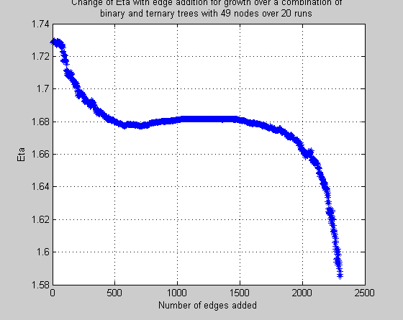

Fig. 9: The change of the parameter Eta with edge addition for growth of a web over a combination binary-ternary tree skeleton with 49 nodes (10 runs)

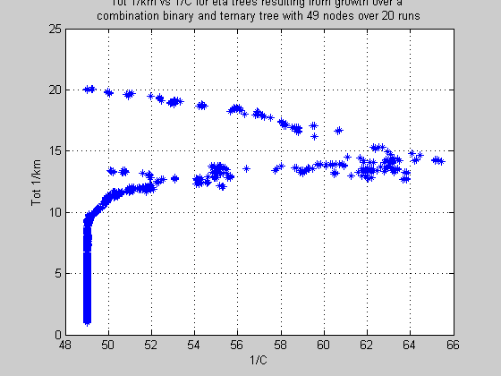

Fig. 10. The relation b/n Total 1/(km) and 1/C for network ‘growth’ over a combination binary-ternary tree and the subsequent reduction to an ‘eta’ tree with 49 nodes averaged over 10 runs

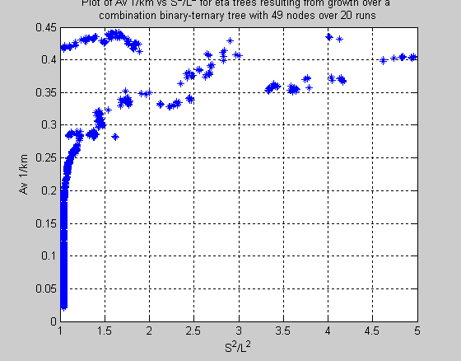

Fig. 11. The relation b/n Average 1/(km) and S²/L² for network ‘growth’ over a combination binary-ternary tree and the subsequent reduction to an ‘eta’ tree with 49 nodes averaged over 10 runs

Comments: The initial spike in the Eta plot is a point of interest as neither the binary nor the ternary trees appear to have it. As it appears to be far too smooth to be an outlier, it is possible that some new features may emerge upon the introduction of uneven vertex degree to the parent tree.

The behavior of the other plots is as expected.

  - Random Eta trees

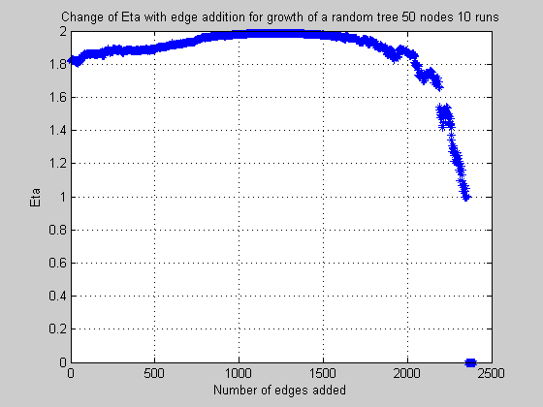

Fig. 12: The change of the parameter Eta with edge addition for growth of a web over a random web with 50 nodes (10 runs)

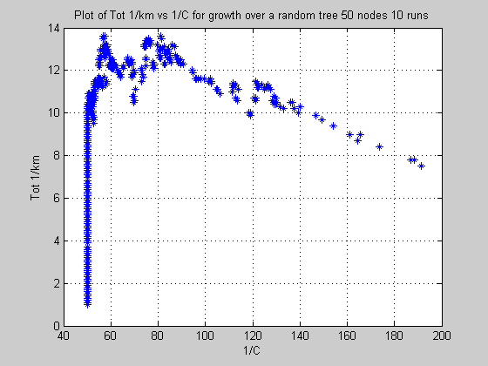

Fig. 13. The relation b/n Total 1/(km) and 1/C for network ‘growth’ over a random web and the subsequent reduction to an ‘eta’ tree with 50 nodes averaged over 10 runs

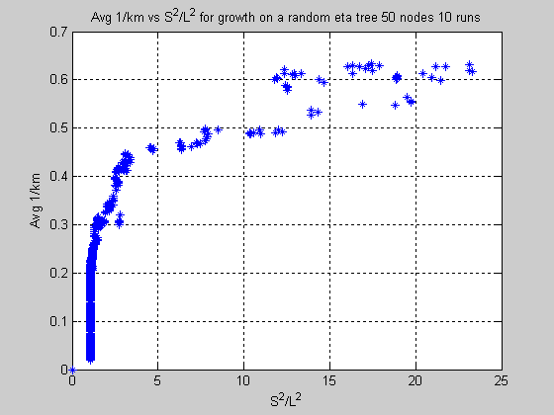

Fig. 13. The relation b/n Average 1/(km) and S²/L² for network ‘growth’ over a random web and the subsequent reduction to an ‘eta’ tree with 50 nodes averaged over 10 runs

Comments: The presence of the few extreme outliers may be explained thus. As the fitting to get the Eta was done using logarithms, log(1) and log(1) may be with exponent 0 . However, this is not thought to present a problem as the reader knows that C is always greater or equal to A thus values of Eta less than 1 may be safely disregarded.

Another surprise seems to be the presence of a sharply defined peak for the Total 1/km plot, similar to that observed when the binary and ternary tree, without being reduced to ‘Eta’ trees, are analyzed to give Tot 1/km. It might suggest that the random tree attempts to achieve order and efficiency by approximating a binary/ternary tree, which poses further questions about network assembly.

The evolution of network structure during the construction of eta trees

The construction of ‘eta’ trees is in a sense an optimization process: the network sheds its unwanted appendages to allow for a more efficient resource transfer. Along the way, an interesting study could be made of the various structures that appear during this process.

As an example, a binary tree with 15 nodes is considered and a few of the resulting ‘eta’ trees are shown below. It is believed that a similar evolution is undertaken by binary trees of a larger number of nodes and other trees.

One fact should be noted here. During the evolution of the ‘eta’ trees, species could switch their roles from top predator to intermediate species and back and other such shifts. This is caused by the selection of the edges joining them to other species and is not expected to hold for natural systems. Still, some lessons may be learnt from the network evolution.

In the food web graphs to follow, the directions of the arrows represent the flow of energy.

